DIET, EXERCISE AND ALCOHOL
We appreciate during periods of isolation and lockdown that people may be more tempted to over indulge or drink more alcohol as well have reduced physical activity. It is important to look after your physical and mental well being during this time.

Diet
The NHS advise the ideal daily intake of calories varies depending on age, metabolism and levels of physical activity, among other things. Generally, the recommended daily calorie intake is 2,000 calories a day for women and 2,500 for men. For more info please refer to:
https://www.nhs.uk/common-health-questions/food-and-diet/what-should-my-daily-intake-of-calories-be/
Remember if you don’t burn off what you consume this will be converted to fat in the body and over time may lead health problems such as diabetes, high cholesterol, high blood pressure, heart and blood vessel disease, fatty liver to name a few or worsen existing health problems.

Alcohol
The recommended weekly alcohol intake for men and women is 14units.
To help you understand:
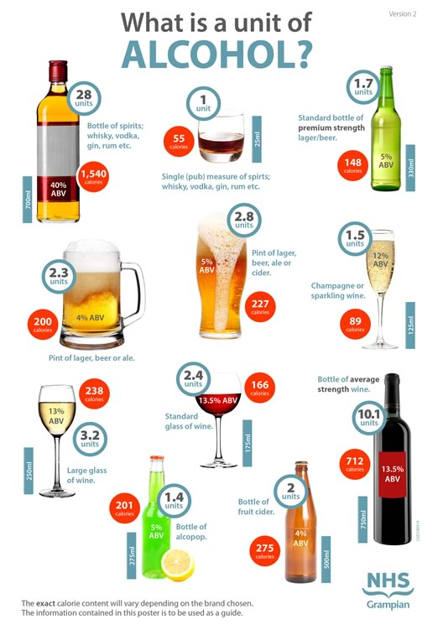
If you are concerned about your alcohol intake and wish to seek further help or advice please refer to: National Alcohol Helpline 0800 314314 8am-11pm or at www.drinksmarter.org or contact us at the medical practice if you feel you need more expert advice.

Exercise
With social distancing many people will have reduced activities due to working from home, suspended access to gyms and leisure activities and outdoor restrictions as well as the general tendency to sit around more at home. We recommend participating in some form of physical activity for at least 30mins either at home or outside whilst adhering to social distancing. And with technology there are so many ways to stay active, why not try the NHS fitness studio: exercise you can do at home found at https://www.nhs.uk/Conditions/nhs-fitness-studio
Or there are loads of other fitness programmes or ideas online if you search for them including apps, or on social media platforms such as you tube, facebook, instagram, pinterest etc

Please see this as a positive opportunity to make changes and be healthy but over all please stay safe.

